To Minimize the Energy Consumption for Communication Protocol using IOT

Project ID: 21116
B.Tech. Project Report
Submitted for fulfillment of
The requirements for the
Degree of Bachelor of Technology
Under Biju Pattnaik University of Technology

Submitted By:
Manisha Panda
ROLL NO: CSE / 201741413
Suman Priya Sahu
ROLL NO: CSE / 201711357


2020 – 2021

Under the guidance of
Mr.Rabindra Kumar Shial

ABSTRACT

Wireless sensor network is defined as wireless network of sensor nodes in which Routing technique is one of the most challenging issues. One of the major issues in WSNs is the limited battery power of the network sensor nodes. The battery power plays an important role in increasing the lifetime of the nodes. In WSN, routing among various routing technique, energy consumption is one of the most important consideration.
To minimize energy consumption hierarchical routing protocols are the best known protocols. LEACH protocol is one of the most energy efficient clustering protocols. Leach increases the network lifetime by consuming a small percentage of the total dissipated energy in the network. In this report, the main focus is on LEACH i.e. an improved energy efficient routing protocol is which saves a significant portion of inner-network communications energy. To do this, the proposed routing protocol selects sensor nodes with higher residual energy, more neighbors, and lower distance from the Base Station (BS) as Cluster Head (CH) nodes. Then, it manages sensor nodes appropriately and constructs clusters such a way to maximize WSN lifetime and minimize average energy dissipation per each sensor node.

NATIONAL INSTITUTE OF SCIENCE & TECHNOLOGY
Palur Hills, Berhampur, Odisha – 761008, India

TABLE OF CONTENTS

ABSTRACT 2
TABLE OF CONTENTS 3
LIST OF FIGURES 4
1. INTRODUCTION 5
1.1 WIRELESS SENSOR NETWORK 5
1.2 ROUTING PROTOCOL ANALYSIS FOR IOT 7
2. LEACH PROTOCOL 9
2.1 FLOWCHART OF LEACH PROTOCOL 10
2.2 WORKING OF WSN 11
2.3 CLUSTERING IN WSN 14
2.4 CLUSTER FORMATION 16

2.5 CLUSTER HEAD ELECTION 16
2.6 DATA TRANSMISSION 19

2.6 ADVANTAGES AND DISADVANTAGES 21

4. CONCLUSION 22
5. REFERENCES 24

LIST OF FIGURES

- Figure1: WSN in Energy Efficiency 6
- Figure 2: Project Analysis Diagram 8
- Figure 3: Base station and cluster head distributions 9
- Figure 4: Algorithm for LEACH protocol 9
- Figure 5: Deployment of Nodes 13
- Figure 6: Direct transmission between sensor nodes 17
And cluster head
- Figure 7: Multi-hop transmission between sensor 17
Nodes and cluster head
- Figure 8: Cluster Formation and Cluster head 18
Selection
- Figure 9: Power Level of the Nodes 18
- Figure 10: Network Performance 19
- Figure 11: Data Dissipation Diagram 20
- Figure 12: Packets send to the Base Station 21

INTRODUCTION

Wireless sensor network (WSN) is a collection of large number of sensor nodes which senses the environment and send data to sink. WSNs also refers to a group of spatially dispersed and dedicated sensors for monitoring and recording the physical conditions of the environment and organizing the collected data at a central location. WSN is used in various fields like military, environment, health, home and other commercial areas. A sensor network design is influenced by many factors like fault tolerance, scalability, production costs, operating environment, transmission media and power consumption. Therefore, it is highly difficult to study energy saving schemes for sensing of dynamic event. For example, a forest monitoring application involves static monitoring approach whereas a target tracking application involves a dynamic monitoring approach.
When a WSN is activated, various tasks are performed to establish the necessary infrastructure to the network, such as distribution of sensor nodes and routing of data transmission, which will allow the sensor node to perform the applications normally. In particular, each node must discover which other nodes it can directly communicate with, and its radio power must ensure the connectivity.
WSNs are usually deployed in an environment to monitor static or dynamic events. The measurement of static events (such as temperature, humidity etc) is very easy to carry out. On the other hand, dynamic events are typically non-cooperative event is the movement of an unwanted vehicle in a battle field and the movement of whales in the ocean. They are not easy to monitor and they are not stable as they go up and down. Sensor network requires certain protocol for efficient performance. For instance, protocol can come in form of a specific application with a defined order to aggregate data and optimizing energy consumption. This kind of protocol is referred to as hierarchical routing. Moreover, we have also a data centric routing protocol which describes a network environment whereby a sensor node also relies on data centric approach which performs sensing application to locate route path from multiple sources to a single destination. With this in mind, data from every node in a network can be describe by a list of attribute value pairs called attribute- based addresses, such that a node can expose its availability to the entire sensor network. It is however essential to improve the energy efficiency for wireless sensor networks as the energy designated for sensor nodes is usually extremely limited. And, due to the fact that there is an increase in societal reliance on wireless sensor network technology, we can foresee the complexity of individual networks as well as huge increment in number of networks.
Due to the nature of the WSN, sensor nodes are normally powered by the use of batteries and thereby having a very constrained budget in terms of energy [1]. To effectively maintain the network sensors to have longer lifetimes, all areas of the network should be carefully designed to be energy efficient. Among many methods, clustering the sensor nodes into groups, so that sensors send information to only the cluster heads (CH) and then the CH communicate the aggregated information to the base stations, may be a good method to minimize energy consumption in WSN. It is necessary to organized sensors in cluster form to reduce energy consumed when transmitting information from nodes to the base station.
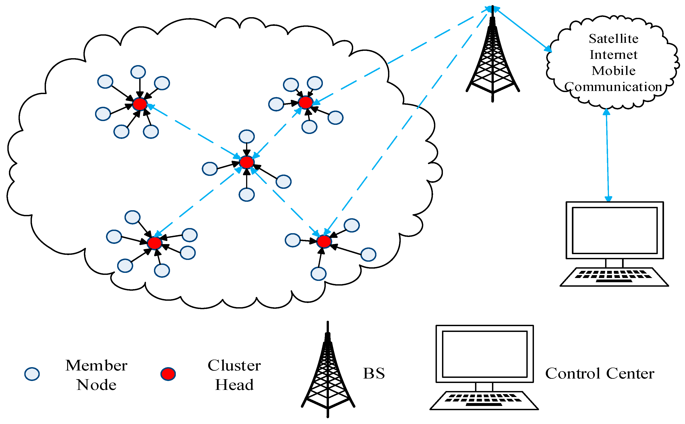

Figure1: WSN in Energy Efficiency

1.2 Routing Protocol Analysis for IOT

Internet of things (IOT) has become an emerging new technology. Things having identities and virtual personalities use intelligent interfaces to connect and communicate within social environmental and user contexts. A routing protocol specifies how routers communicate with each other to distribute information that enables them to select routes between any two nodes on a computer network.
In order to cope with the limitations of the IOT systems, a routing protocol should meet specific requirements and employ different strategies. Such a protocol needs to match the traffic pattern of its deployment area and be resourceful in terms of power consumption. Also, it has to scale in terms of memory and performance, while being able to cope with sparse location changes. Moreover, an IOT routing protocol is required to recognize and avoid one-way links and be conservative on the transmitter energy usage. Last but not least, supporting IPv6 and mobility are considered as essential qualities. The strategies used include proactive routing, by trying to have a global view of the whole network topology at all times, and reactive routing, by searching the routes on demand
Routing bears significant importance since nodes in an IOT network act as hosts and routers delivering data to the gateways. The routing of data from source to destination impacts the power consumption of forwarding nodes.
->The routing of data from source to sink is an integral part of any large-scale wireless sensing and Internet of Things (IOT) solution.
-> A routing protocol can release the potential of any complex network that is characterized by some dynamic factors such as changing topology and flow. Thus to achieve the full functionality of IOT, routing protocols are needed for device to device communication in IOT.
->In order to turn this IOT vision into reality, routing protocols are needed to aid the communication between these things in a self-organized manner.

IOT exists at a higher level than WSN. In other words, WSN is often a technology used within an IOT system. A large collection of sensors, as in a mesh network, can be used to individually gather data and send data through a router to the internet in an IOT system. It's also important to note that the term "wireless sensor network" is not nearly as encompassing as "the internet of things." WSN consists of a network of only wireless sensors. If the network was to include a wired sensor, it could no longer be labeled a "wireless sensor network." This is unlike IOT. Essentially any device that connects
to the internet can be considered an IOT device. An "IOT system" can therefore be interpreted as a group of many IOT devices. An IOT system, all of the sensors directly send their information to the internet. For example, a sensor may be used to monitor the temperature of a body of water. In this case, the data will be immediately or periodically sent directly to the internet, where a server can process the data and it can be interpreted on a front-end interface. Conversely, in a WSN, there is no direct connection to the internet. Instead, the various sensors connect to some kind of router or central node. A person may then route the data from the router or central node as they see fit. That being said, An IOT system can utilize a wireless sensor network by communicating with its router to gather data. In IOT, many physical objects are attached to convert the information while using the Internet. Moreover, the technology of WSN provides the foundation for IOT systems and supports in observing and forwarding the conditions for the physical environment.
Wireless sensor networks (WSNs), which are associated with IOT, represent useful networks in assisting the monitoring, tracking and sensing different environmental activities. Sensors characteristics play the main role in designing and applying any WSN . With the rapid technological development of sensors, WSNs will become the key technology for IOT. Wireless sensors can empower multiple IOT applications to produce endless opportunities.

LEACH PROTOCOL

This is a hierarchical clustering-based routing protocol used for WSN design. In this protocol, cluster heads are changed randomly and one by one all the nodes become cluster heads as shown in Figure 2. For scalability and robustness, LEACH uses localized coordination for the dynamic network and does data aggregation at the cluster head level. Thus, the data transmitted to the sink are reduced and bandwidth is saved.
The LEACH protocol’s basic flow diagram is shown in Figure 3. The clustering system procedure begins with a setup step in which all nodes use an indicator function to pick CHs. This process is given in Figure 3. The chosen cluster heads then broadcast an Advertisement (ADV) message using the non-persistent protocol which includes CH’s ID (also called CHID).

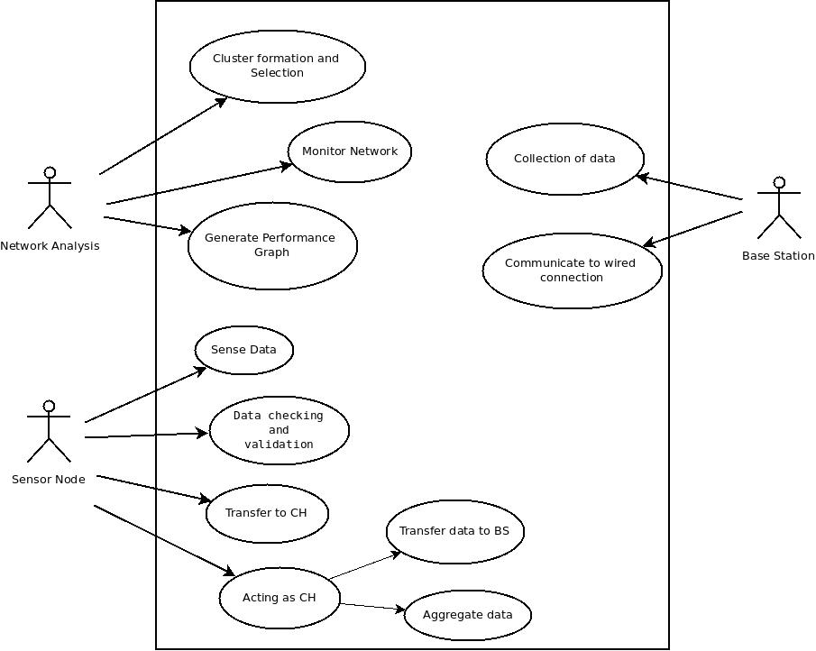
Figure 2: Project Analysis Diagram

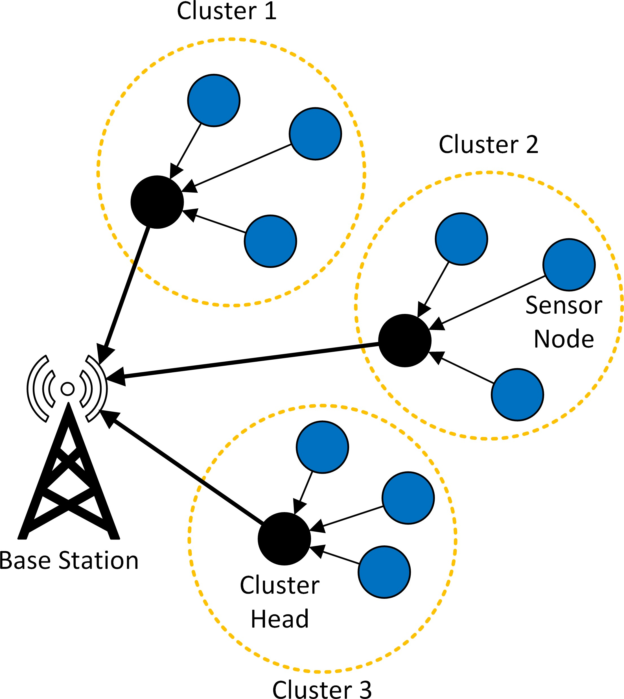
Figure 3: Base station and cluster head distributions.

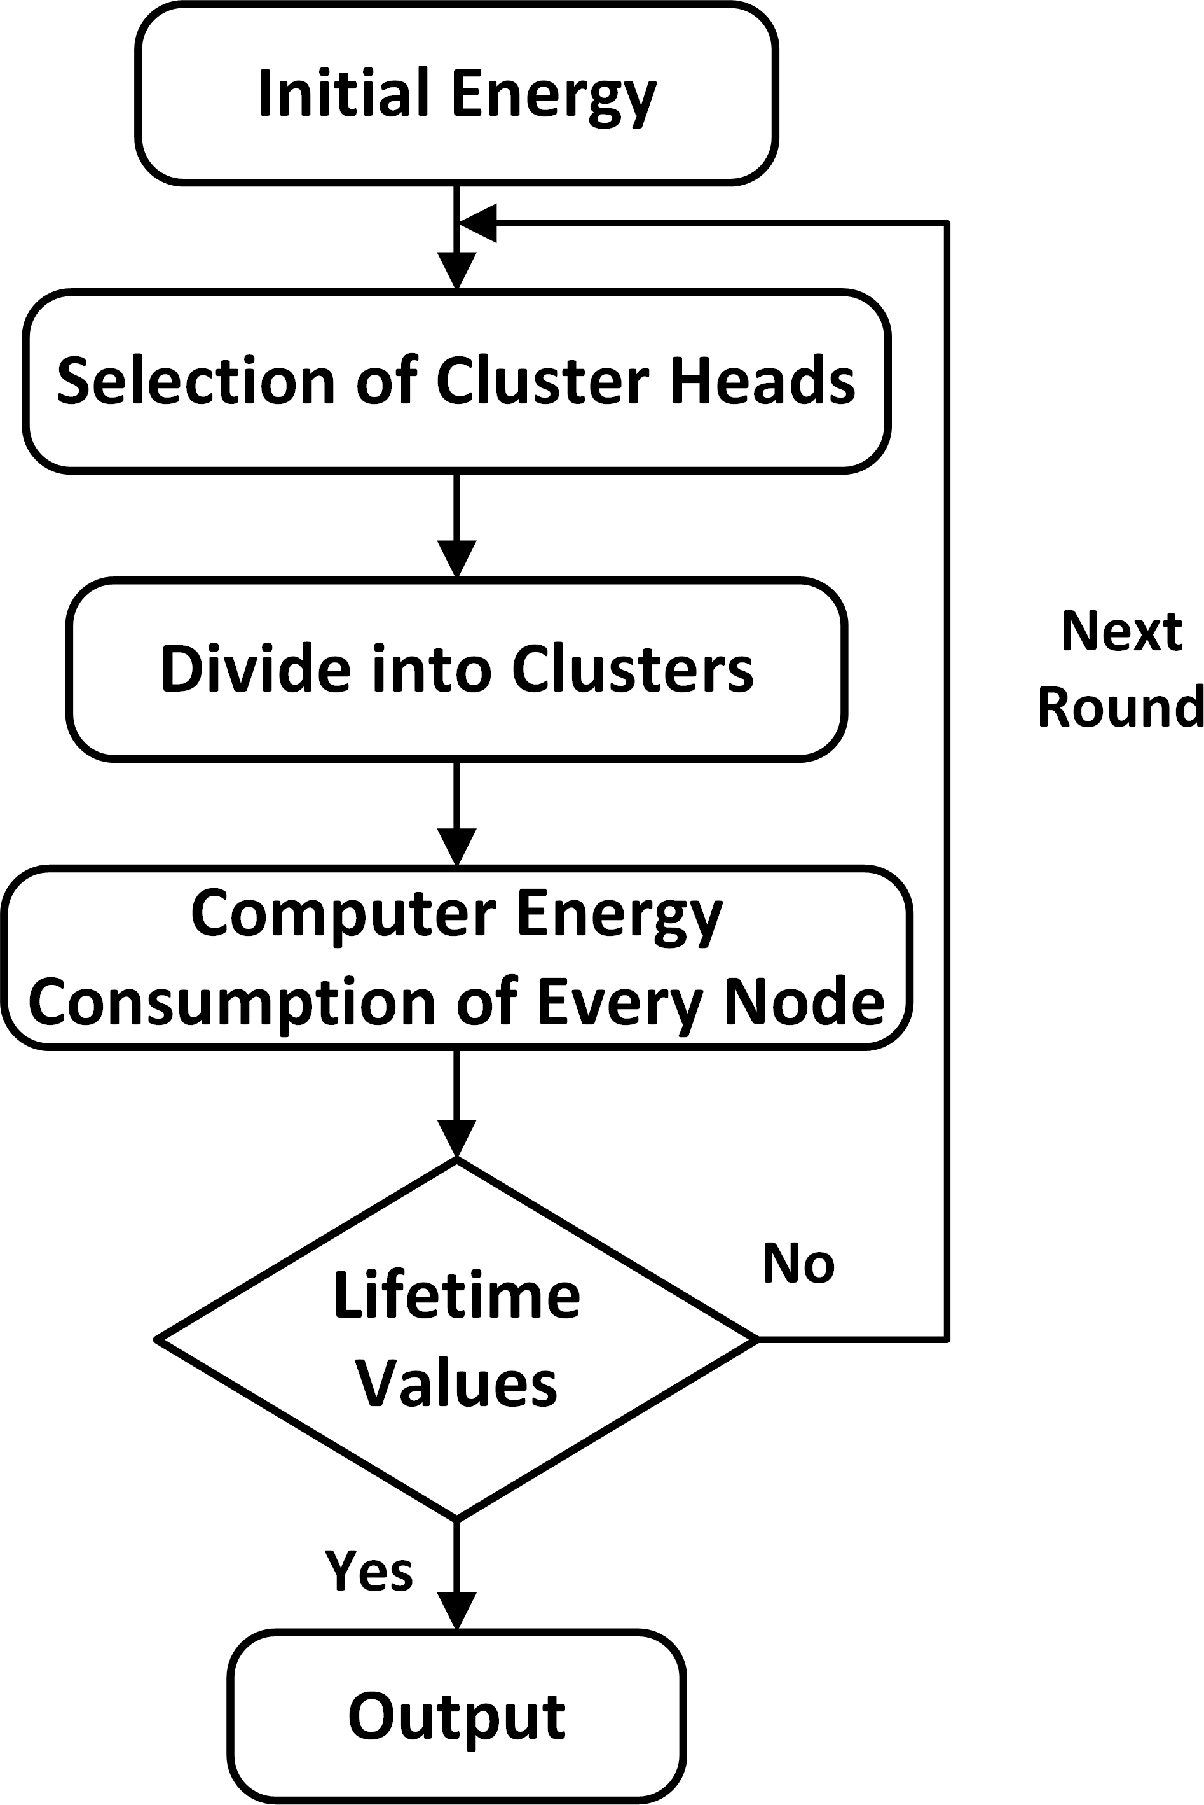
Figure 4: Algorithm for LEACH protocol

Sensor networks consist of a large number of small independent devices. Each device, called a sensor node, is battery powered and equipped with integrated sensors, data processing, and Short-range radio communication capabilities. A significant amount of research has been done in the area of connecting large numbers of these sensors to create robust and scalable Wireless Sensor Networks (WSNs). Although individual sensor nodes have limited Capabilities, WSNs aim to be energy efficient, self-organizing, scalable, and robust. A Substantial amount of research has cantered on meeting these challenges.
The large deployment of WSNs and the need for energy efficient strategy necessitate efficient organization of the network topology for the purpose of balancing the load and prolonging the network lifetime. Clustering has been proven to provide the required scalability and Prolong the network lifetime. Due to the bottle neck phenomena in WSNs, a sensor network Loses its connectivity with the base station and the remaining energy resources of the functioning nodes are wasted.

2.2 WORKING of Leach Protocol

- As LEACH is a hierarchical protocol in which most nodes transmit to cluster heads, and the cluster heads aggregate and compress the data and forward it to the base station (sink). The cluster head then creates a schedule for each node in its cluster to transmit its data.
- In this the LEACH protocol adopts the method of distributed CH election, in which some nodes are randomly selected from the network as CHs, and other nodes become cluster member nodes.
- The CH broadcasts the message that it becomes a CH, and other nodes select the CH with the strongest received signal to join to form a cluster.
- The cluster member node collects data and transmits it to the CH, which receives data and transmits it to the BS through single-hop communication. The CHs undertake the heavy tasks, including managing the member nodes of the cluster, collecting the data transmitted by the member nodes, data fusion, and intercluster forwarding. Therefore, to balance the energy consumption of nodes, CHs rotate, and the cluster structure is updated periodically.
LEACH Protocol has two phases:
  - The Set-up Phase
  - The Steady-State Phase
The Set-Up Phase where the cluster head are chosen.
The Steady-State Phase where the cluster head is maintained where the data is transmitted between the nodes.

Notation:
N: number of nodes CH: cluster head BS: a base station

Setup Stage:

In this stage, clusters are made and CHs are chosen

For Each (N)
N selects a random number T (n) between 0 and 1 If (T (n) < threshold value)
N becomes a Cluster-Head
N transmits a message announcing its CH status Else
N becomes a typical node
N receives the announcing message of CHs End if
End for
For Each (CH)
Calculate a distance from N to CH and from CH to BS
N chooses the CH with minimum distance from it to CH to BS N appraises the selected Cluster-Head and becomes a cluster part
End for

For Each (CH)
TDMA schedule is made by Cluster-Head for each node to transfer data TDMA schedule is advertised to each node in the cluster by Cluster-Head
End for

Notation:
N: number of nodes.
CH: cluster head
Steady-state Stage:

For Each (N)
N gathers data that has been sensed
N transfers the data that has been sensed into the Cluster-Head in the corresponding TDMA time point
End for
For Each (Cluster-Head)
Cluster-Head gets data from the cluster nodes Cluster-Head aggregates the data
Cluster-Head transfers the data to the base station
End for

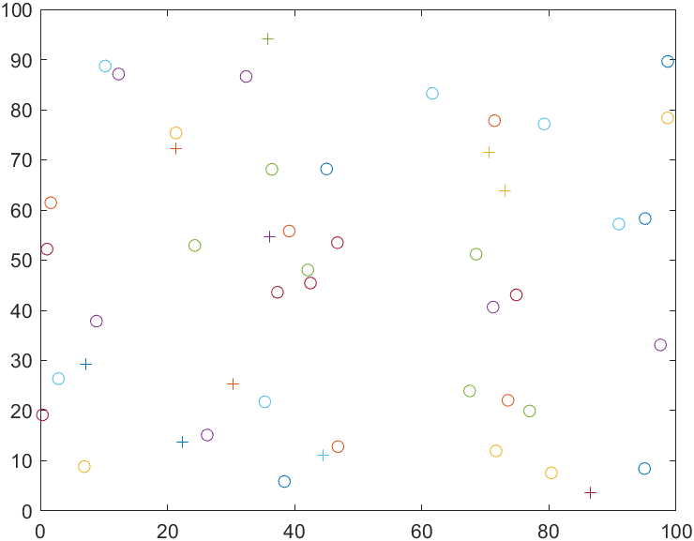

Figure 5: Deployment of Nodes

2.3 Clustering in Wireless Sensor Network

Clustering is a method by which sensor nodes are hierarchically organized on the basis of their relative proximity to each other. Hierarchical (sensor nodes clustering) energy consumption creates an effective and reliable means of routing collected data from the physical environment, through the sensor nodes to the BS. Clustering of sensor nodes helps to compress the routing table such that the discovery mode between sensor nodes is done more easily. Clustering can also conserve communication bandwidth because it limits the scope of inter-cluster interactions to CHs and avoids redundant exchange of messages among sensor nodes. Each sensor node performs a route table look up for the CH in its region and then routes its collected data to the CH. The CH performs a route discovery estimation based on shortest distance to a recipient CH closer to the BS or directly to the BS. In order to maintain the routing table, link information is exchanged from time to time between sensor nodes to adapt to the change in energy requirement for data transmission by all nodes.

2.4 Cluster Formation and Rotation

With the evolving trend in application and management of WSN, clustering provides an efficient means of managing sensor nodes in order to prolong its lifetime. Several clustering formation technique have been develop in the past such as random competition based clustering (RCC) [18]. RCC algorithm uses random timer and node identification for cluster formation is based on First Declaration Wins Rule. This rule assigns governorship position to any node which declares itself first as being a CH to other nodes in its radio network.
Furthermore, there are other approaches to cluster formation and an example of that is the broadcasting technique. Broadcasting can simply be described as when one sensor node is sending a packet to all other sensor node in wireless sensor network. It should be noted that not all broadcast messages are useful and also some of the messages sent by the sensor node are dropped because a sensor nodes status has already been assigned and cannot be changed.
In direct broadcasting technique, cluster advertisement message is sent to all sensors within a selected region. For instance, two clusters formation requires two random nodes are selected for broadcasting. This randomly selected node is known as an initiator. All initiators broadcast a cluster advertisement message to all sensor nodes in the network. If any node in the network that is not an initiator receives an advertisement message within the cluster, it sends a message to the initiator from which the message was received. It will not only send a reply but also refrain from accepting any other cluster advertisement message for that simulation round. Such a sensor node will however become a part of this initiator’s cluster.
The technique of direct broadcasting is very simple when it comes to its implementation but it is not cost effective in terms of energy consumption. This is due to the fact that all sensor nodes receive a broadcast from the CH. The sensor nodes that are very far to the CH will still need to receive broadcast but it does not mean that the sensor will respond to the message. But, in a situation where a sensor node receives a broadcast from an initiator, the subsequent broadcast message will be dropped, and energy which is used in transmission will be underutilized.
Multi-hop broadcasting on the other hand uses specific transmission range to transmit a cluster advertisement message to the sensor nodes. It is the duty of the receiving node to proceed in sending the cluster advertised message to all the sensor nodes in its transmission range. This technique works very closely to direct broadcasting technique for the fact that it also selects an initiator node that sends cluster advertisement messages at the start of cluster formation. These techniques use a concept which is known as minimum communication energy which means that the sensor node that is easiest to reach will form part of the initiator cluster [4]. Also, when cluster are formed dynamically, the reorganization is done on a periodic basis. The initiator is selected at the beginning of every period and broadcasted messages are sent out using one of the above-mentioned methods for cluster organization. The multi-hop broadcasting minimizes the problem of energy usage. This is due to the fact that there is a limit for transmission because the highest amount of energy that can be wasted is the minimum transmission energy of neighboring sensor nodes. This will create no need for the sensor nodes which are far away from each other to transmit directly. It has a disadvantage in the sense that it has more delay when compared to the former technique of broadcasting. This is because, in multi-hop broadcasting, the data are required to be processed by each sensor node along the multi-hop path, which creates delay in the formation of cluster. However, the multi-hop is much better than the direct broadcast if the problem of delay is taken care of.

2.5 Cluster Head Selection

After cluster formation, CHs are designated which act as a leader in each clusters. Cluster heads are saddled with the responsibility for data aggregation and performing routing for its cluster member’s information to the base station. Also, the clusters that consist of many nodes have a higher burden than clusters with fewer nodes as the CHs for those large-sized clusters have to receive, aggregate and transmit more data.
A CH can be elected randomly or pre-assigned by the designer of the network. A CH can also be elected by taking into consideration the residual energy of nodes in the cluster. The CHs are known to have higher burdens than member nodes; therefore, the role of CH is rotated to share the burden and thus improving the useful lifetime of those clusters.
In random selection, a node is selected randomly as CH, based on the probability that it has never being selected during the entire lifetime of the network. This reduces the traffic burden on a CH since the role of CH is spread throughout the sensor nodes. The rotation is done at a periodic interval. Whereas, in the residual energy selection, the sensor node that has the highest amount of energy in the cluster is selected as the cluster head. It will continue to remain the CH until the energy drops below the average energy of the entire cluster. So, rotation of CH is done at every instance when its energy level drops below the average cluster energy. This rotation of CHs will lead to the overall energy of the sensor network being evenly distributed. This technique eventually improves the lifetime of the network. Another approach to cluster head selection is based on minimizing the distance to cluster nodes as this offers reduction in energy usage during data transmission to the BS. With this method of minimizing sum of distances to CH, the cluster formation is better enhance to reduce energy usage as transmission takes place. It helps in reducing the unnecessary energy which the sensor node uses in communicating with the CH by minimizing the transmission distances from sensor node to any CH.
Since communication energy is an important concept to consider in wireless transmission, it is known that energy greatly depends on distance. Therefore, it is very good idea to minimize the distance in transmitting data from sensor nodes to base station via the CH, as this helps to reduce the communication energy in wireless sensor network.

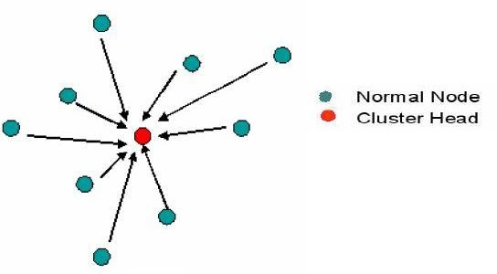
Figure 6: Direct transmission between sensor nodes and cluster head

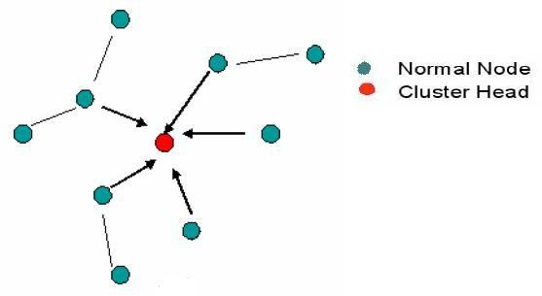
Figure 7: Multi-hop transmission between sensor nodes and cluster head

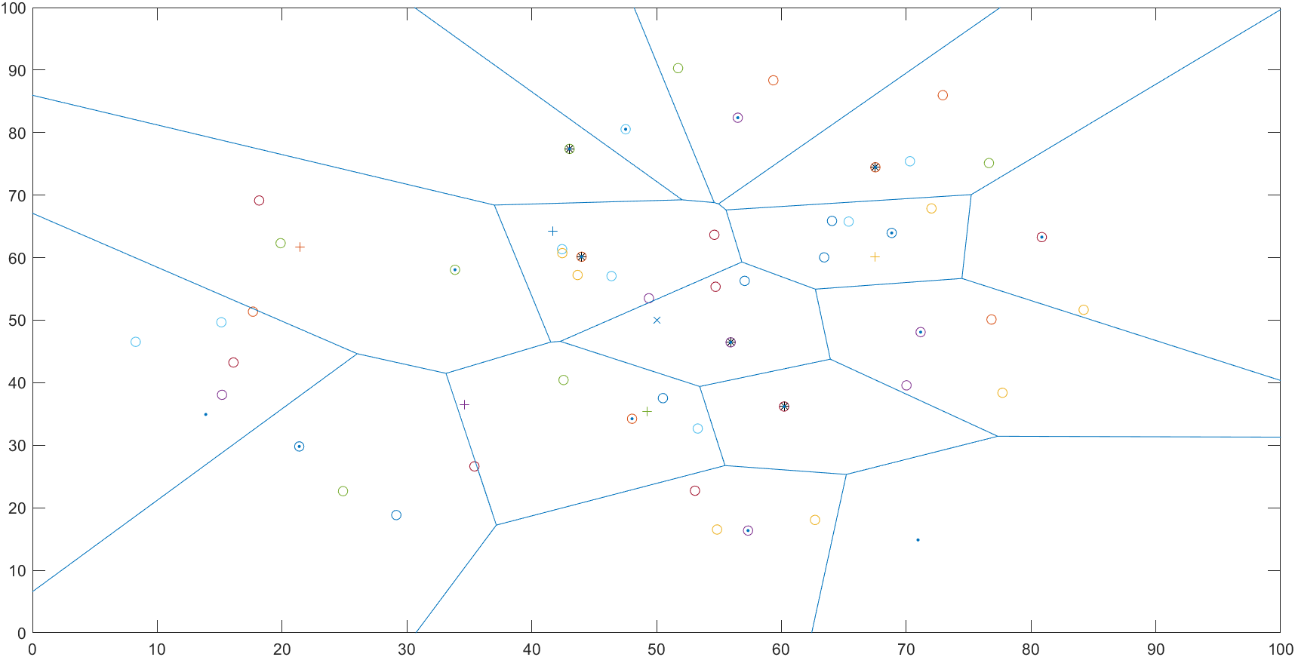

Figure 8: Cluster Formation and Cluster head Selection

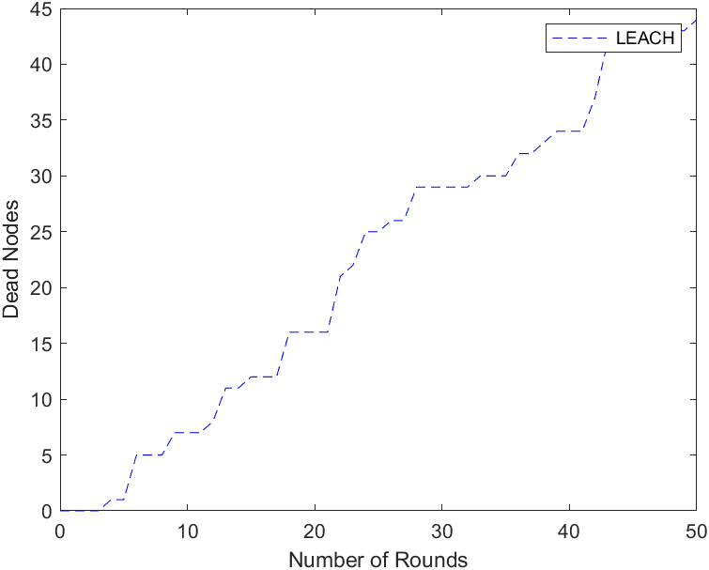

Figure 9: Power Level of the Nodes

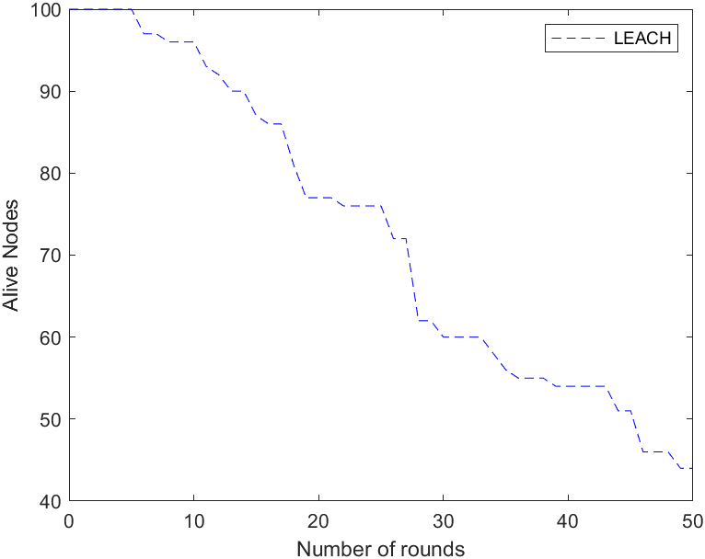

Figure 10: Network Performance using Leach

2.6 Data Transmission

Once the clusters are created and the TDMA schedule is fixed, data transmission can begin. Assuming nodes always have data to send, they send it during their allocated transmission time to the cluster head. This transmission uses a minimal amount of energy (chosen based on the received strength of the cluster-head advertisement). The radio of each non-cluster-head node can be turned off until the node’s allocated transmission time, thus minimizing energy dissipation in these nodes. The cluster-head node must keep its receiver on to receive all the data from the nodes in the cluster. When all the data has been received, the cluster head node performs signal processing functions to compress the data into a single signal. For example, if the data are audio or seismic signals, the cluster-head node can beam form the individual signals to generate a composite signal. This composite signal is sent to the base station. Since the base station is far away, this is a high-energy transmission. This is the steady-state operation of LEACH networks. After a certain time, which is determined a priori, the next round begins with each node determining if it should be a cluster-head for this round.

The amount of transmitted data and the total quantity of data sent from the nodes in the WSN to base station calculated by:
Data =dataCHtoBS + dataNtoBS.

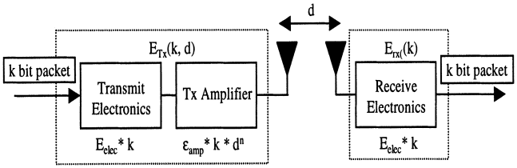
Figure 11: Data Dissipation Diagram

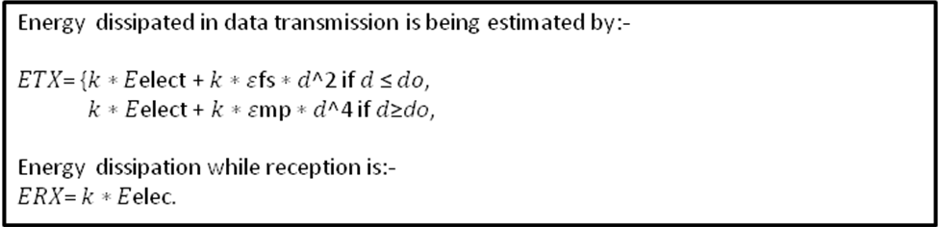

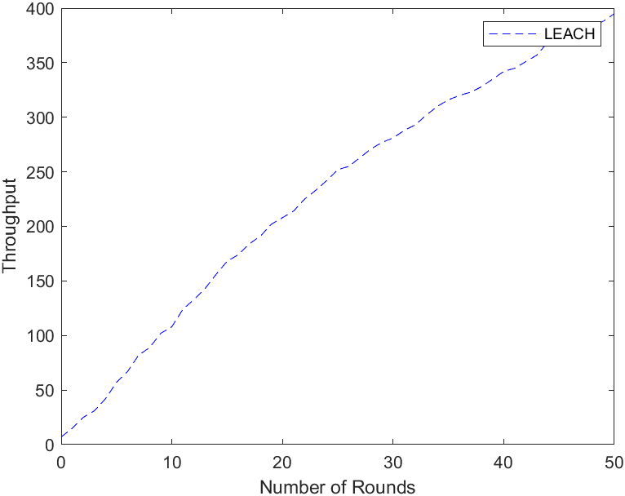
Figure 12: Packet Sends to the Base Station

2.7 Advantages and Disadvantages

- The cluster head aggregates the whole data which lead to reduce the traffic in the entire network.
- As there is a signal hop routing from nodes to cluster head if results in saving energy.
- It increases the lifetime of the sensor network.
- In this, location information of the nodes to create the cluster is not required.
- LEACH is completely distributed as it does not need any control information from the base station as well as no global knowledge of the network is required.
Besides the advantages of LEACH it also has some demerits which are as follows:
- LEACH does not give any idea about the number of cluster heads in the network.
- One of the biggest disadvantage of LEACH is that when due to any reason Cluster
head dies, the cluster will become useless because the data gathered by the cluster nodes would never reach its destination i.e. Base Station.
- Clusters are divided randomly, which results in uneven distribution of Clusters. For e.g. some clusters have more nodes and some have lesser nodes. Some cluster heads at the center of the cluster and some cluster heads may be in the edge of the cluster; this phenomenon can cause an increase in energy consumption and have great impact on the performance of the entire network

CONCLUSION

An energy efficient hierarchical routing technique in which cluster heads are elected based on the prediction of transmission energy via a shortest distance to the base station. Our approach applies a geographical formation of sensor nodes into clusters, rotating the role of CH, and optimizing the CH selection by prediction of energy transmission energy in every rounds of simulation, and aggregating data before transmission to the BS. The important features which includes cluster formation and rotation, cluster head election and rotation, and cluster optimization of our proposed hierarchical routing technique in transmitting data to the base station was analyzed and emphasized. Our analysis shows that energy efficiency of WSNs can be further improved by using the hierarchical routing technique. The concept of hierarchical routing technique can be effectively used to designed energy efficient routing protocol in WSN. In our approach, the clusters are formed geographically into different sizes to see how it could affect the network lifetime of WSN. With energy awareness protocol being our core interest in this thesis work, our proposed hierarchical technique, which uses the predict of smallest transmission energy via the shortest path possible to send data to the BS proof to offer more reduced energy consumption and also increase the lifetime of the WSN. From the analysis of our simulation results, we found out that our proposed protocol offers a better solution to energy efficiency usage in a WSN when compared to other technique such as LEACH and non hierarchical technique.
The validation of our technique by further evaluating the second level hierarchy in which three cluster were formed in the network, and observed an improved network lifetime which indicate a better energy efficiency in the WSN. In future work, the optimal level of hierarchy, that is, if we increase the number of clusters to four, five, six and so on, can be investigated. Therefore, we can see how the lifetime in the network would be affected and the optimal cluster size would also be known in case the lifetime is reduced at a certain level of hierarchy. This work can also be extended to the optimization of the number of sensor nodes in each cluster such that they could be organized into cluster equally such as the method of base-station controlled clustering protocol to solve the problem of uneven data traffic in sensor network. The validation of our proposed technique can also be done in matlab to have a better view and understanding of the result analysis. Furthermore, in routing of packets in wireless sensor networks, some sensor node energy is wasted on relaying others data instead of using its energy own data. Therefore, limiting the energy of the nodes that has little or no energy is another area of future research. One can also take account the communication cost and its impact on network lifetime.

REFERENCE

- Ruchi Sharma, Gunjan Jain and ShashiKant Gupta, "Enhanced Cluster-head Selection Using Round Robin Technique in WSN", 2015 International Conference on Communication Networks.
- Zhiyong Peng and Xiaojuan Li, The Improvement and Simulation of LEACH Protocol for WSNs, IEEE, 2010.
- Salim E.L. Khediri, Nejah Nasri, Anne Wei and Abdennaceur Kachouri, A New Approach for Clustering in Wireless Sensors Networks Based on LEACH, Elsevier, 2018.
- R.P. Mahapatra and R.K. Yadav, "Descendant of LEACH based routing protocols in wireless sensor networks", Procedia Comput. Sci., vol. 57, pp. 1005-1014, 2015.
- L. Yadav and C. Sunitha, "Low energy adaptive clustering hierarchy in wireless sensor network (LEACH)", Int. J. Comput. Sci. Inf. Technol., vol. 5, no. 3, pp. 4661-4664, 2014

